**How to install the Vmware in windows**

* **To download the Vmware in windows go to the VMware official website** [**https://www.vmware.com/in/products/workstation-pro/workstation-pro-evaluation.html**](https://www.vmware.com/in/products/workstation-pro/workstation-pro-evaluation.html)**.**
* **After download the Vmware go the download folder and double click the folder it ask install yes or no click the yes.**
* **Click on the Next to installation wizard**
* 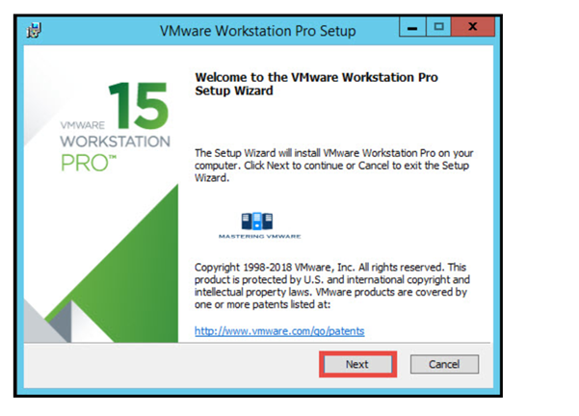
* **Read the accept the vmware end user license agreement.click on next**

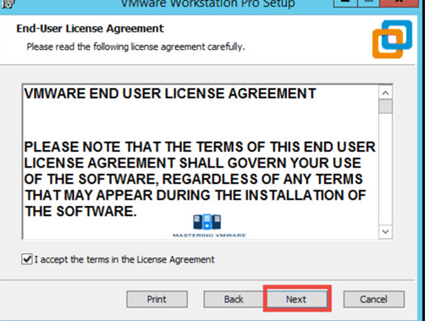

* **To specify the destination path of the vmware**

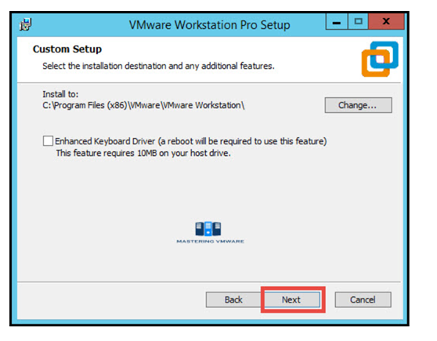

**To select the shortcuts you want to create for easy access to VMware workstation.**

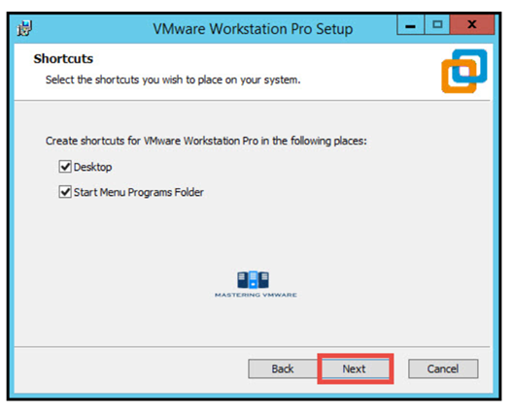 **click install button to start the installation**

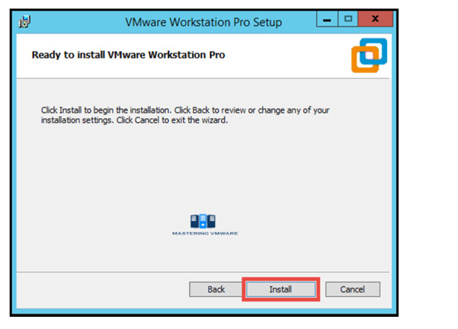

**Click Finish to exit the wizard**

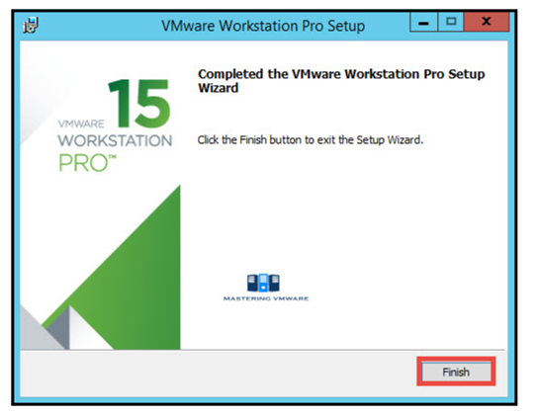

**After finish the above process the screen will show**

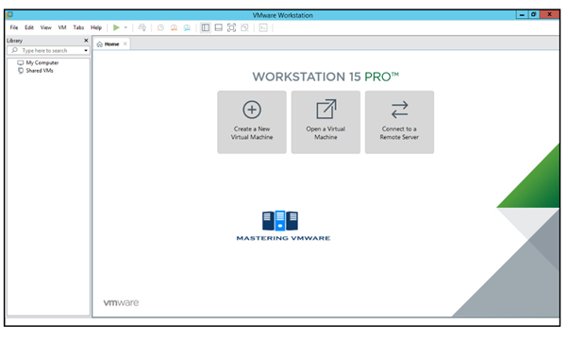

**Vmware was successfully installed**

**How to install the ubuntu live server in Vmware**

**Create the New Virtual machine in Vmware**



**You can choose either Typical or Custom Wizard. We recommend selecting Custom if you want to install with all the configurations. If you are okay with default configurations then go ahead with Typical configurations.**

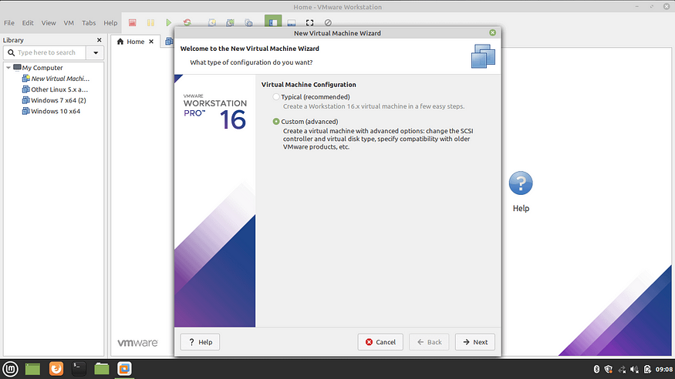

**Select Virtual Machine Hardware Compatibility**

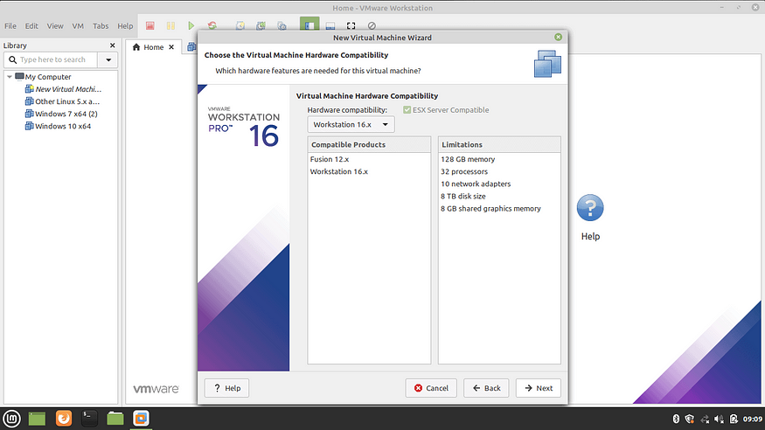 **Select the Operating System Media**

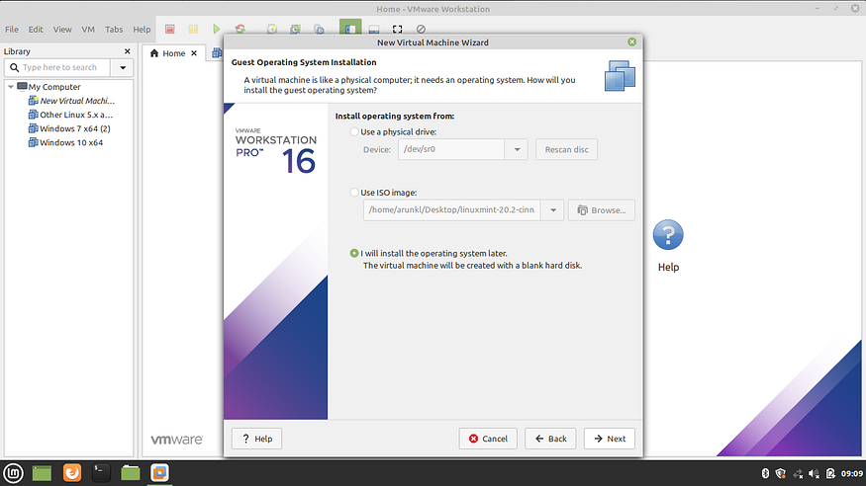 **Select Guest Operating System**

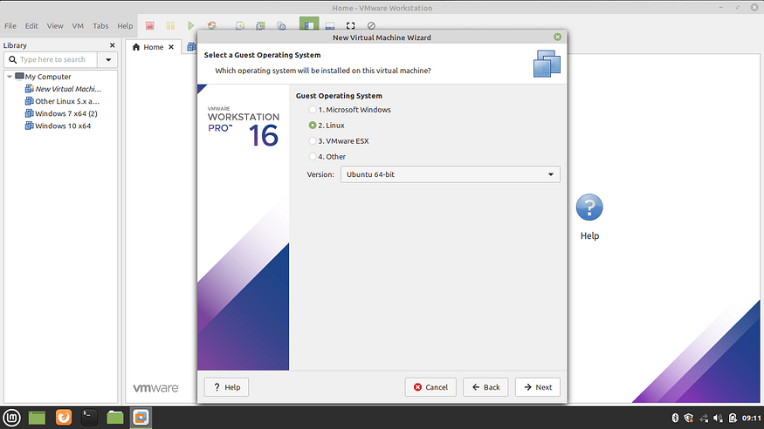

**Name the Virtual Machine Name and location**

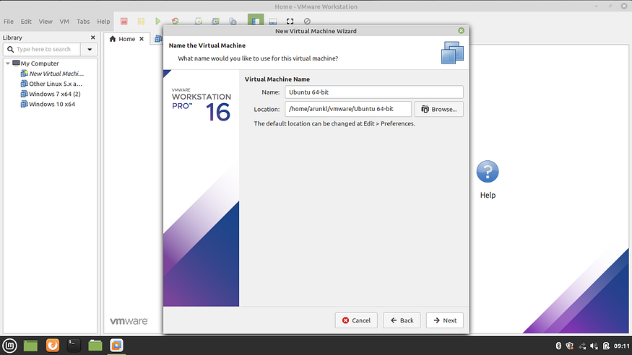

**Allocate the Processors**

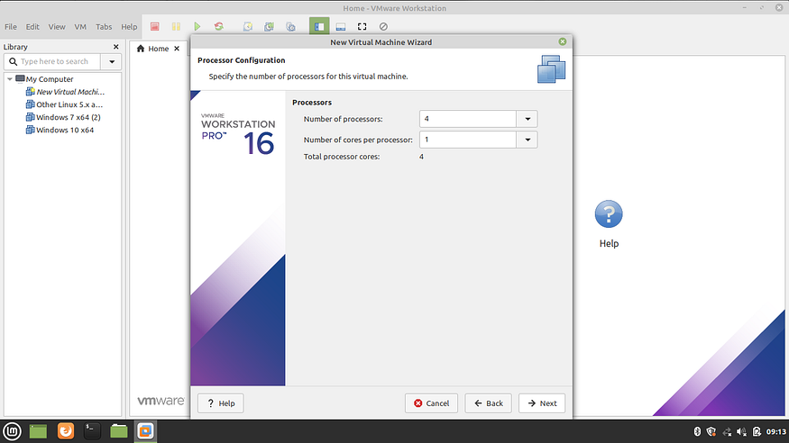

**Allocate the Memory for Virtual Machine** 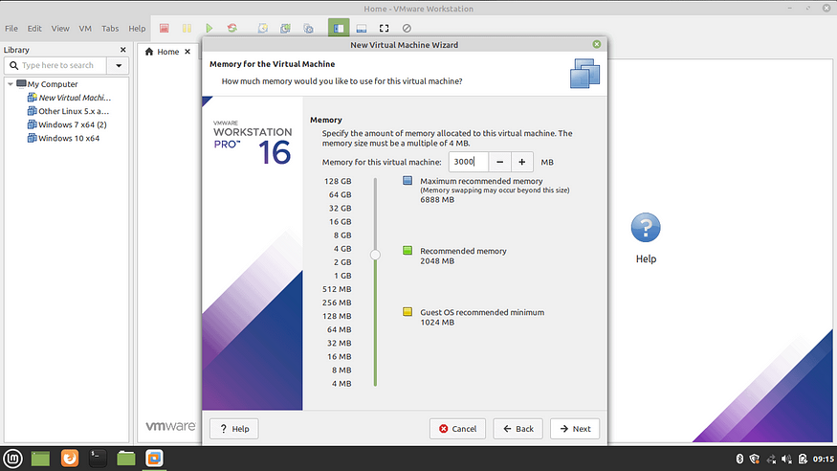

**9. Choose the Network Configuration**

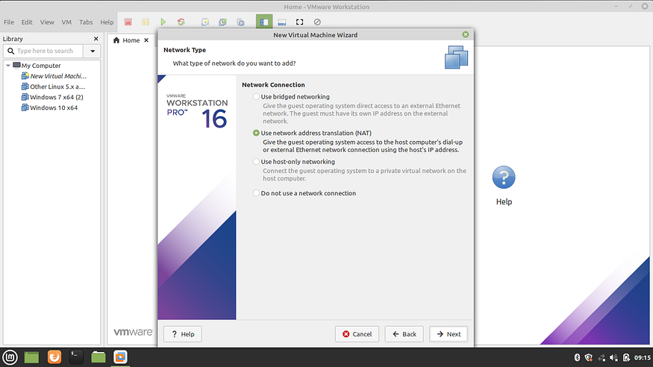

**Select the I/O Controller Type**

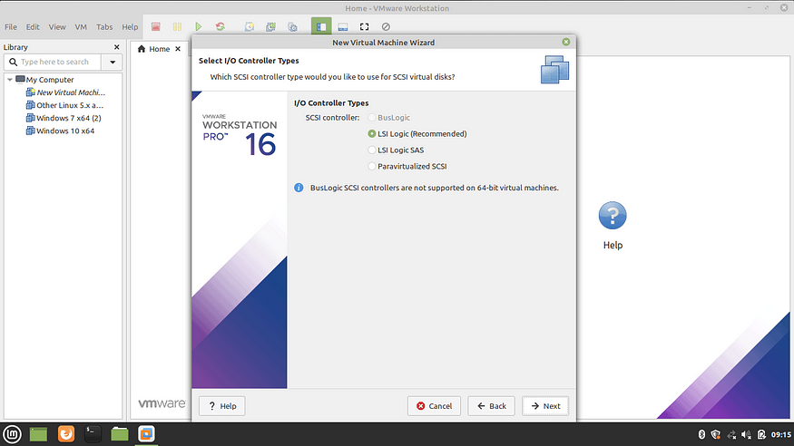

**Select disk type**

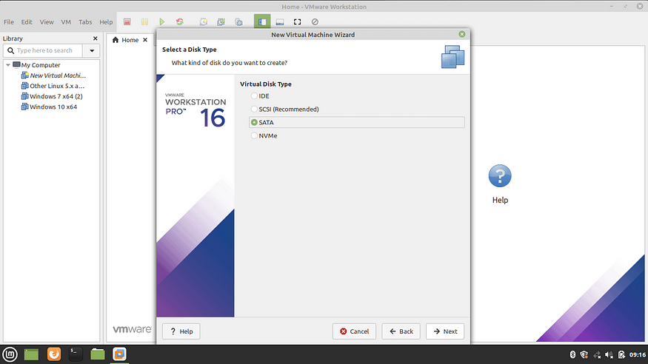

**Select virtual disk**

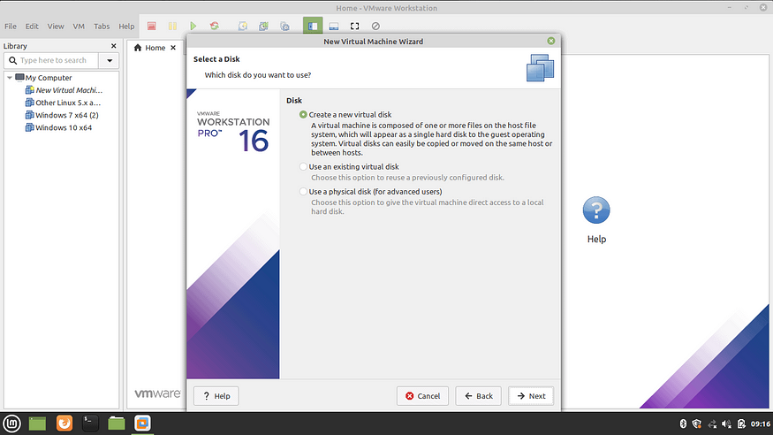 **Select Disk Capacity**

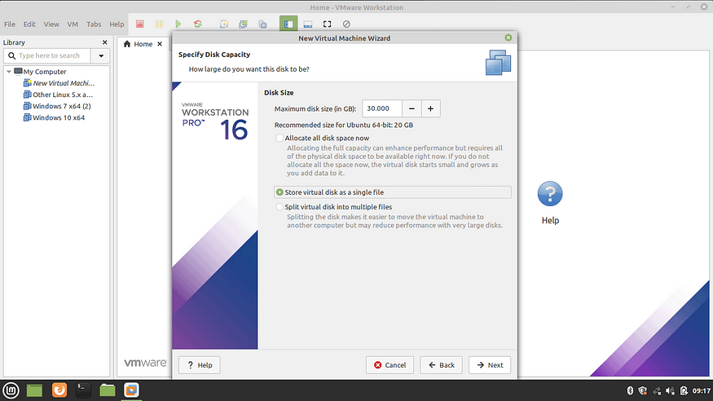

**Specify Virtual Disk File**

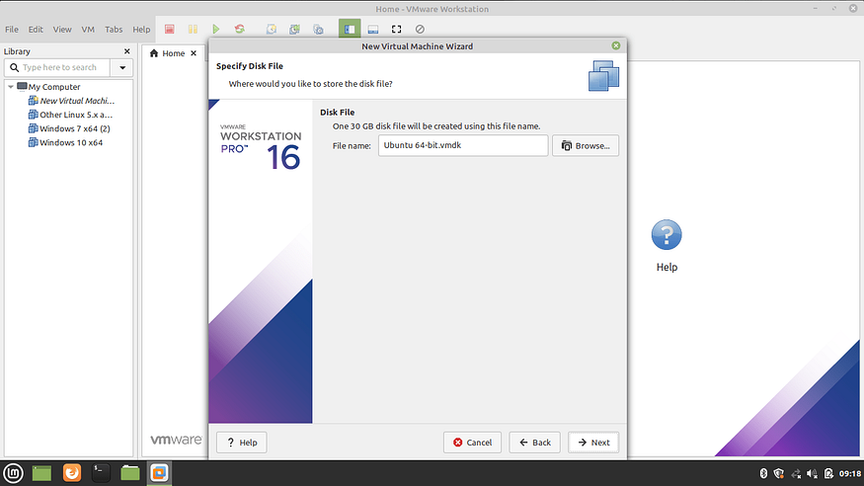

**Create a virtual machine**

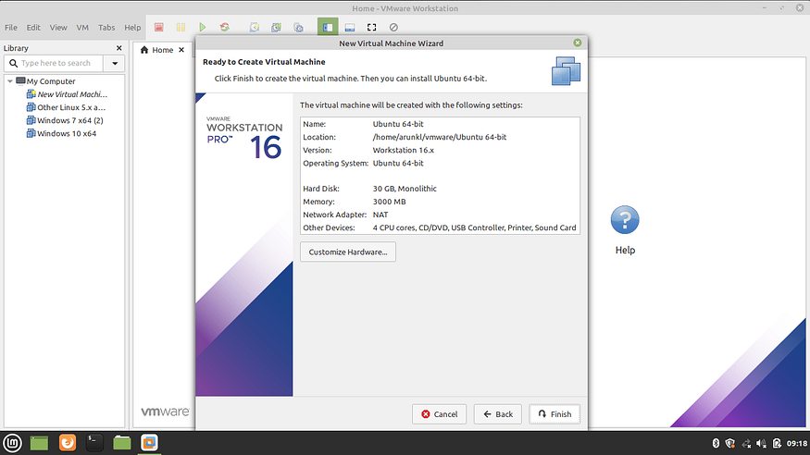

**Click on the finish .**

**After that power on the virtual machine**

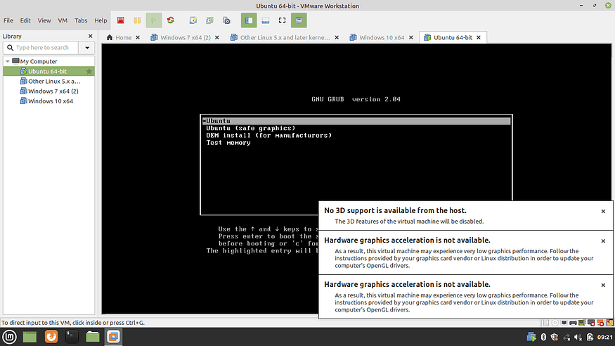

**After that the screen will show you welcome select the language**

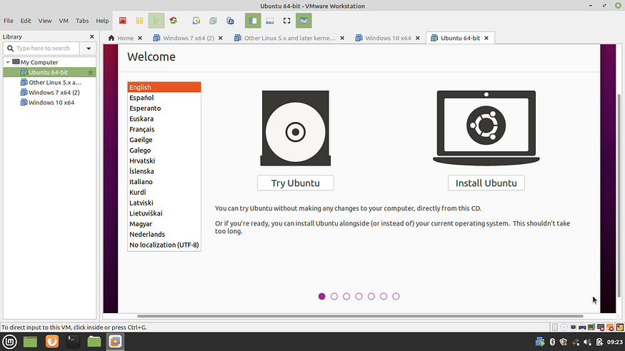

**Create a admin account**

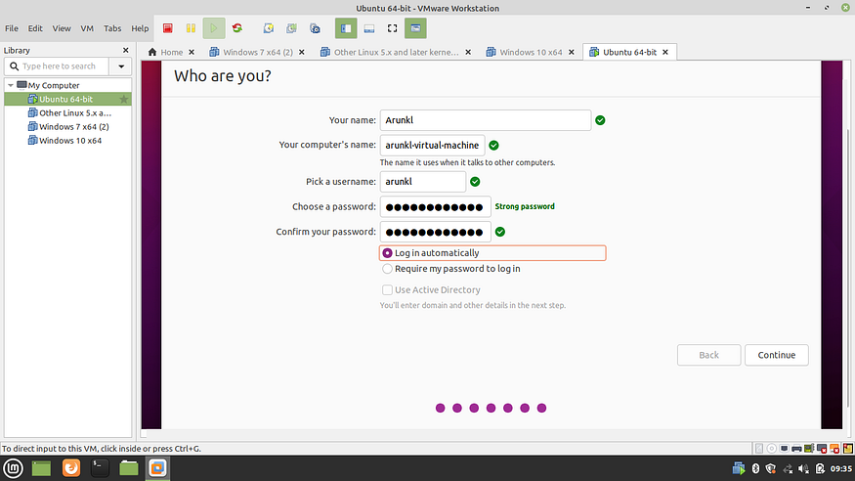

**You can choose password and user name of the server**

**After that complete process the system was update and restart.**